Intermuscular spaces in scapular region
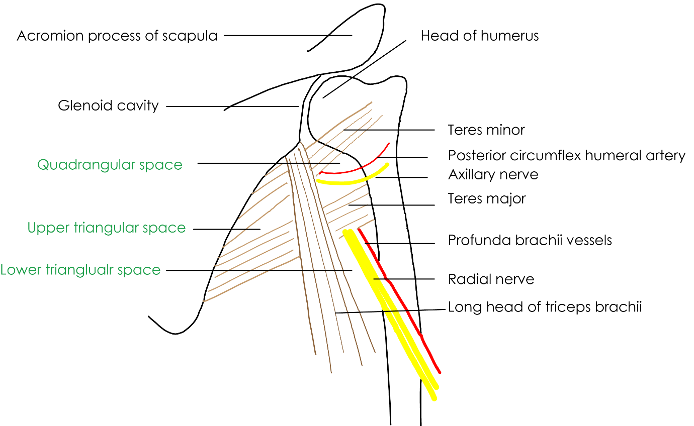

Space | Boundaries | Contents
Quadrangular space | Superior: teres minor  Inferior: teres major  Medial: long head of triceps  Lateral: neck of humerus | Axillary nerve  Posterior circumflex humeral vessels
Upper triangular space | Superior: teres minor  Inferior: teres major  Lateral: long head of triceps | Circumflex scapular artery
Lower triangular space | Medial: long head of triceps  Lateral: shaft of humerus  Superior: teres major | Radial nerve  Profunda brachial vessels

[TIP]Watch the video
[YOUTUBE] https://www.youtube.com/watch?v=IT4okibSU7I

